
SECP1513-02
TECHNOLOGY AND INFORMATION SYSTEM

Design Thinking Project Report
Project Title: UTM Smart Cafeteria
Prepare for: Dr Shafaatunnur binti Hasan
Group 4:

PHOTO | NAME | MATRIC ID
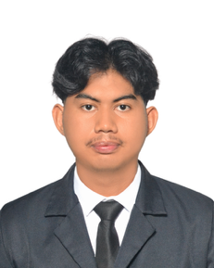 | ADAM BIN BAHARUDDIN | A25CS0170
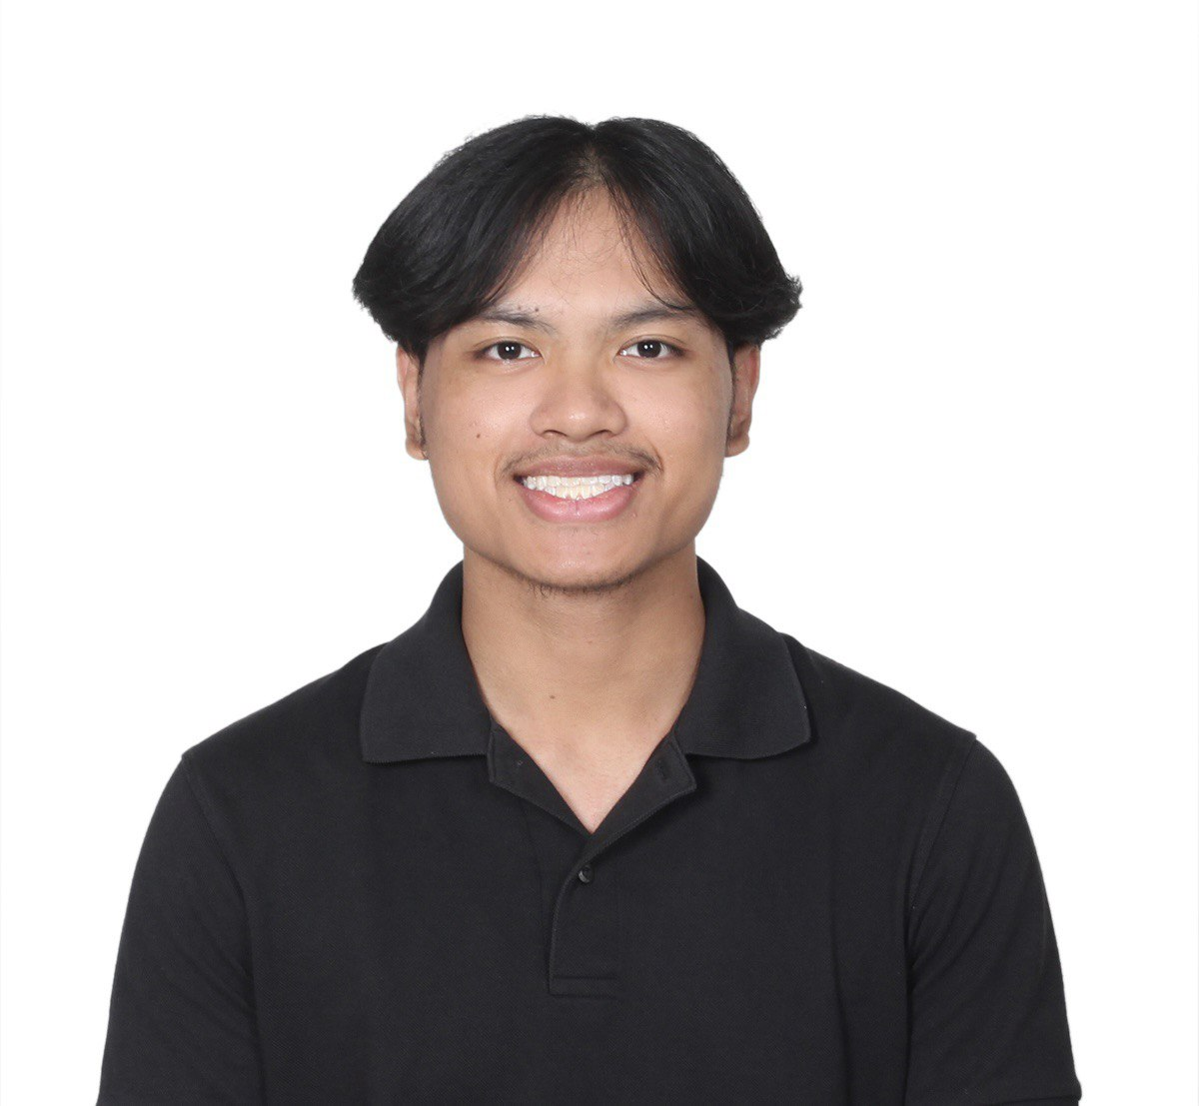 | ADAM FAHIM MOHD FOAD | A25CS0038
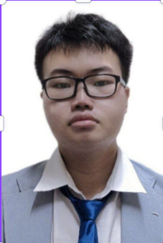 | SIA JUN YANG | A25CS0138
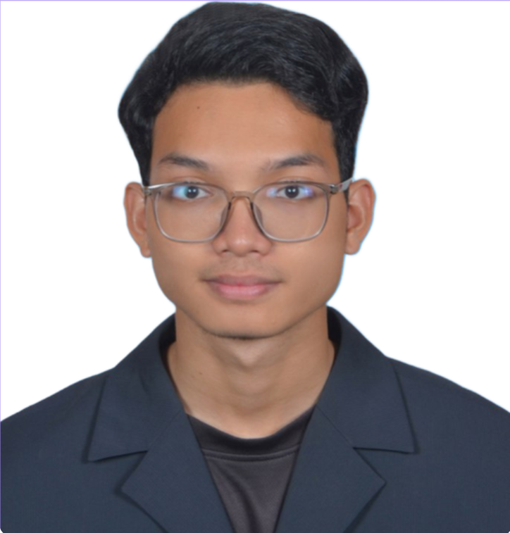 | AFIF RIFQI BIN SHAIFUL REZAL | A25CS0174

TABLE OF CONTENT

INTRODUCTION 4
What is Design Thinking? 4
DETAIL STEPS 5
DETAIL DESCRIPTIONS 7
DESIGN THINKING ASSESSMENT POINT 8
DESIGN THINKING EVIDENCE 10
Emphasize Phase 10
Define Phase 10
Ideate Phase 11
Prototype Phase 11
Testing Phase 12
REFLECTIONS 13
CONCLUSION 15
TASK DISTRIBUTION 16

INTRODUCTION

What is Design Thinking?

Design thinking is a non-linear, iterative process that teams use to understand users, challenge assumptions, redefine problems and create innovative solutions to prototype and test. It is most useful to tackle ill-defined or unknown problems.
Design Thinking consists of five phases:

Phases | Description
Empathize | The first phase of is empathize, which is crucial because it requires a deep understanding of users’ needs, experiences, and motivations by setting aside personal assumptions and observing them in their environment to gain genuine insight.
Define | The second phase is define, which is about a human-centered, iterative approach to creative problem solving that focuses on deeply understanding user needs to develop innovative, practical solutions, balancing desirability, feasibility, and viability through empathize, define, ideate, prototype and test phases.
Ideate | Ideate is the phase where it is focused on generating a large quantity of diverse, creative solutions to a user-centered problem, moving from “how might we” questions to exploring wild idea, suspending judgement, and embracing divergent thinking to fuel future prototypes and innovation.
Prototype | Prototype is a tangible simplified model of a potential solution, created to quickly test ideas, gather user feedback, and iterate before full development, saving time and resources by identifying flaws early and validating assumptions.
Test | Test is the iterative, final phase where prototypes are evaluated with real users to gather feedback, refine solutions, and deepen empathy, revealing what works and doesn't before full implementation.

DETAIL STEPS
Our group decided to make a prototype about Universiti Teknologi Malaysia (UTM) Smart Cafeteria. We identified that the cafeteria's system in UTM is not too efficient as it is too crowded, the number of seats is not enough to accommodate the number of people that wants to eat at the cafeteria, the shops they want to order food from is closed, the menu of the certain shop and many more. Hence, our group made the Universiti Teknologi Malaysia’s (UTM) Smart Cafeteria prototype to improve the efficiency of Universiti Teknologi Malaysia’s (UTM) cafeteria system by providing the people information about the cafeteria such as the amount of people at the cafeteria, the availability of seats, the shops that are opened, the type of food the shop serves and many more.
- Empathize
For the first stage of our design thinking we used a Google Form and conducted an interview session to gain an opinion regarding the cafeteria system at Universiti Teknologi Malaysia (UTM). The google form consisted of multiple-choice questions and multiple answers questions to gain quantitative data regarding the cafeteria's system. This will provide us a clear vision on what needs to be improved.

- Define
From the Google Form and interview session it was found that cafeteria users often struggle with long waiting times, less meal options, no available seats, unfamiliar with the menu and prices at the cafeteria and cashless payments are still not available. According to the information collected the problems that needs to be attended to are clear.

- Ideate
The information collected was utilised to generate different ideas to solve the problems regarding the cafeteria. Several meetings were held between the members to share their ideas. Mind-mapping was used to finalise the many different ideas that were shared. It was decided that the Universiti Teknologi Malaysia’s (UTM) Smart Cafeteria system was developed to further enhance the experience of cafeteria users.

- Prototype
The finalised ideas in the mind-map were used to make a paper prototype to imagine the outcome of the system including visualising, testing, and refining before the full deployment of the system. The system's services include the menu and price of the shops, seat availability, open or closed status of the shops and cashless payments system of the shops.

- Test
The finished paper prototype was tested by having the cafeteria users use the prototype to simulate system usage and observe the effectiveness of the system. Feedback was also requested to improve the system and further cater to the needs of the cafeteria users.

DETAIL DESCRIPTIONS
Project Overview: UTM Smart Cafeteria Feature Integration
- Problem Identification
The current cafeteria system at UTM lacks real-time information. Students often waste time walking to the cafeteria (Arked) only to find it overcrowded and no seat. Besides, students also cannot know the food menu and its prices and whether the cafeteria is closed or not. Furthermore, manual payment or ordering can lead to misunderstandings or "scams" where orders are wrongly claimed.

- Proposed Solution
We propose adding a "UTM Cafeteria" feature within the existing UTM Smart App. This centralizes information and provides a secure, digital ordering process.

- Key Features (Based on Sketch Design)
- Crowd Level Indicator: Each cafeteria (e.g., Arked Meranti, Arked Cengal) shows a status of "Low," "Medium," or "High" traffic, helping students avoid peak hours.
- Digital Menu & Pricing: Students can view a full list of food and beverages with their respective prices (e.g., Sizzling RM 7.00) before visiting.
- Estimated Wait Time: The system displays how long it will take to prepare the food (e.g., 10 minutes), allowing for better time management.
- Secure Receipt & Anti-Scam Mechanism: After ordering, a digital receipt is generated. Students must show this specific digital proof to the vendor to redeem their food. This prevents others from claiming the wrong order and ensures payment transparency.

DESIGN THINKING ASSESSMENT POINT

Empathize
We created a Google form to survey UTM students in order to understand the challenges they face when buying food at campus cafeterias. This survey collected insights on common problems such as long queues, uncertainly about which cafeteria is crowded, difficulty viewing menus and prices, unclear operating hours, and potential issues with payments. The data gathered helped us identify real user needs, which guided of features for the propesed UTM Smart Cafeteria system.

Define
Based on the user insights, the main problem is that the currency cafeteria system lacks transparency, efficiency, and reliable information. Users face difficulties in planning their meals due to unknown crowd levels, unclear menus and prices, limited operating information, and unsafe manual transaction processes. Therefore, the system is needed to improve convenience, trust, and overall dining experiences at UTM cafeterias.

Ideate
In this stage, solutions are generated to address the identified problems. The proposed ideas include real-time cafeteria crowd monitoring, digital menus with updated prices, clear display of operating hours and days, and a secure cashless ordering systems. Another key idea is providing electronic receipts that users can use to redeem their food, ensuring transprency and preventing scams of misunderstanding.

Prototype
The prototype of the UTM Smart Cafeteria is a digital platform, such a mobile application or web system, that integrates all proposed features. The prototype include a user interfsce for viewing crowd levels, menus, prices, and cafeteria schedules, as well as a vendor dashboard for order management. A digital receipt system is also included to support easy food redemption and transaction verification.

Test
The testing stage evaluates how well the Smart Cafeteria meets user needs. Feedback from UTM students can be collected to clarity of information and efficiency of the ordering process. Results are expected to show reduce waiting time, improved user satisfaction, fewer ordering errors, and do student more trust due to transparent pricing and secure receipt-based food redemption.

DESIGN THINKING EVIDENCE

Emphasize Phase
We have created a Google Form to conduct a survey to get more opinions and information from a huge range of people.

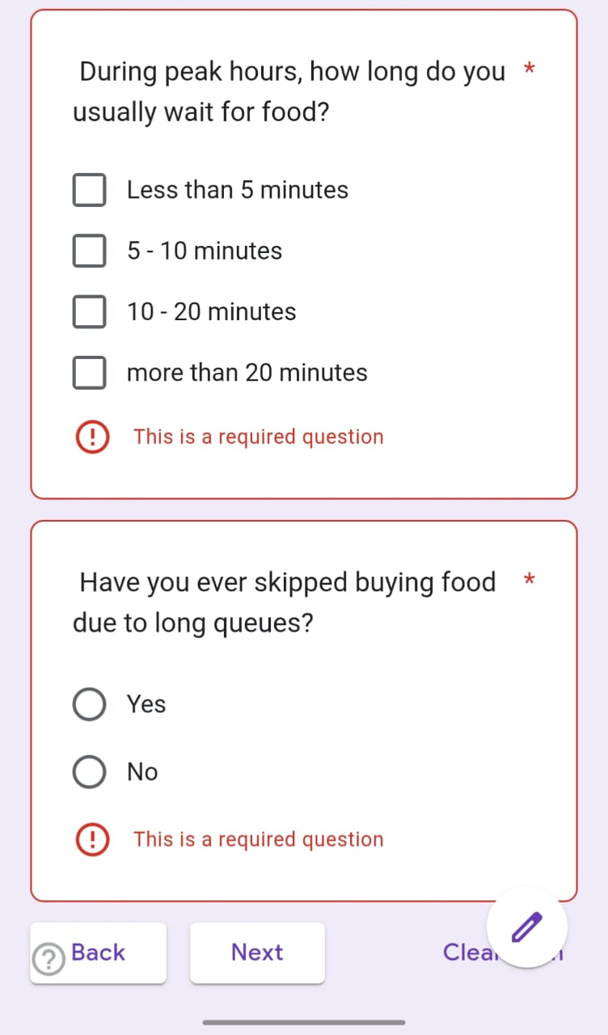 | 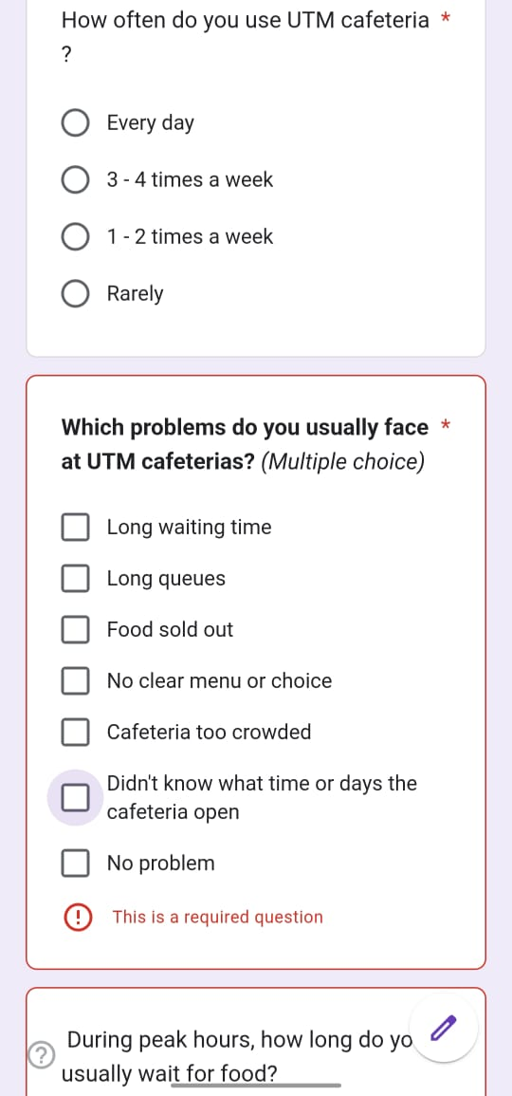
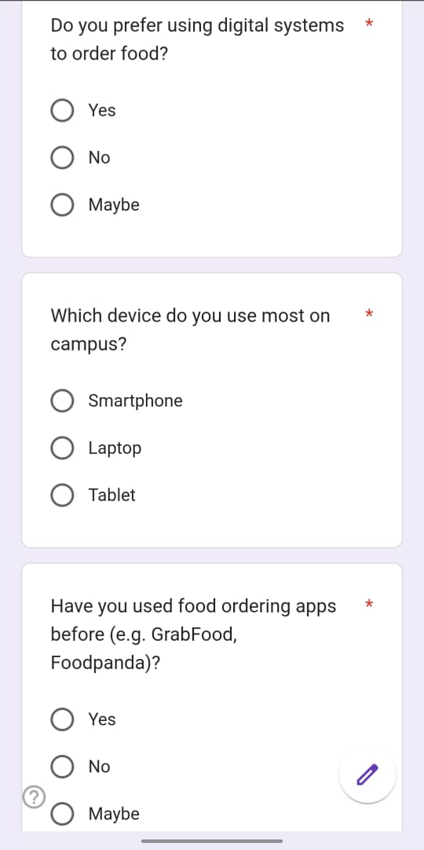 | 

Define Phase
During this phase, we collected the data from the interview session and Google Form survey. This helped us to understand the problems they faced and make us to have a better idea to design the solutions based on their needs.
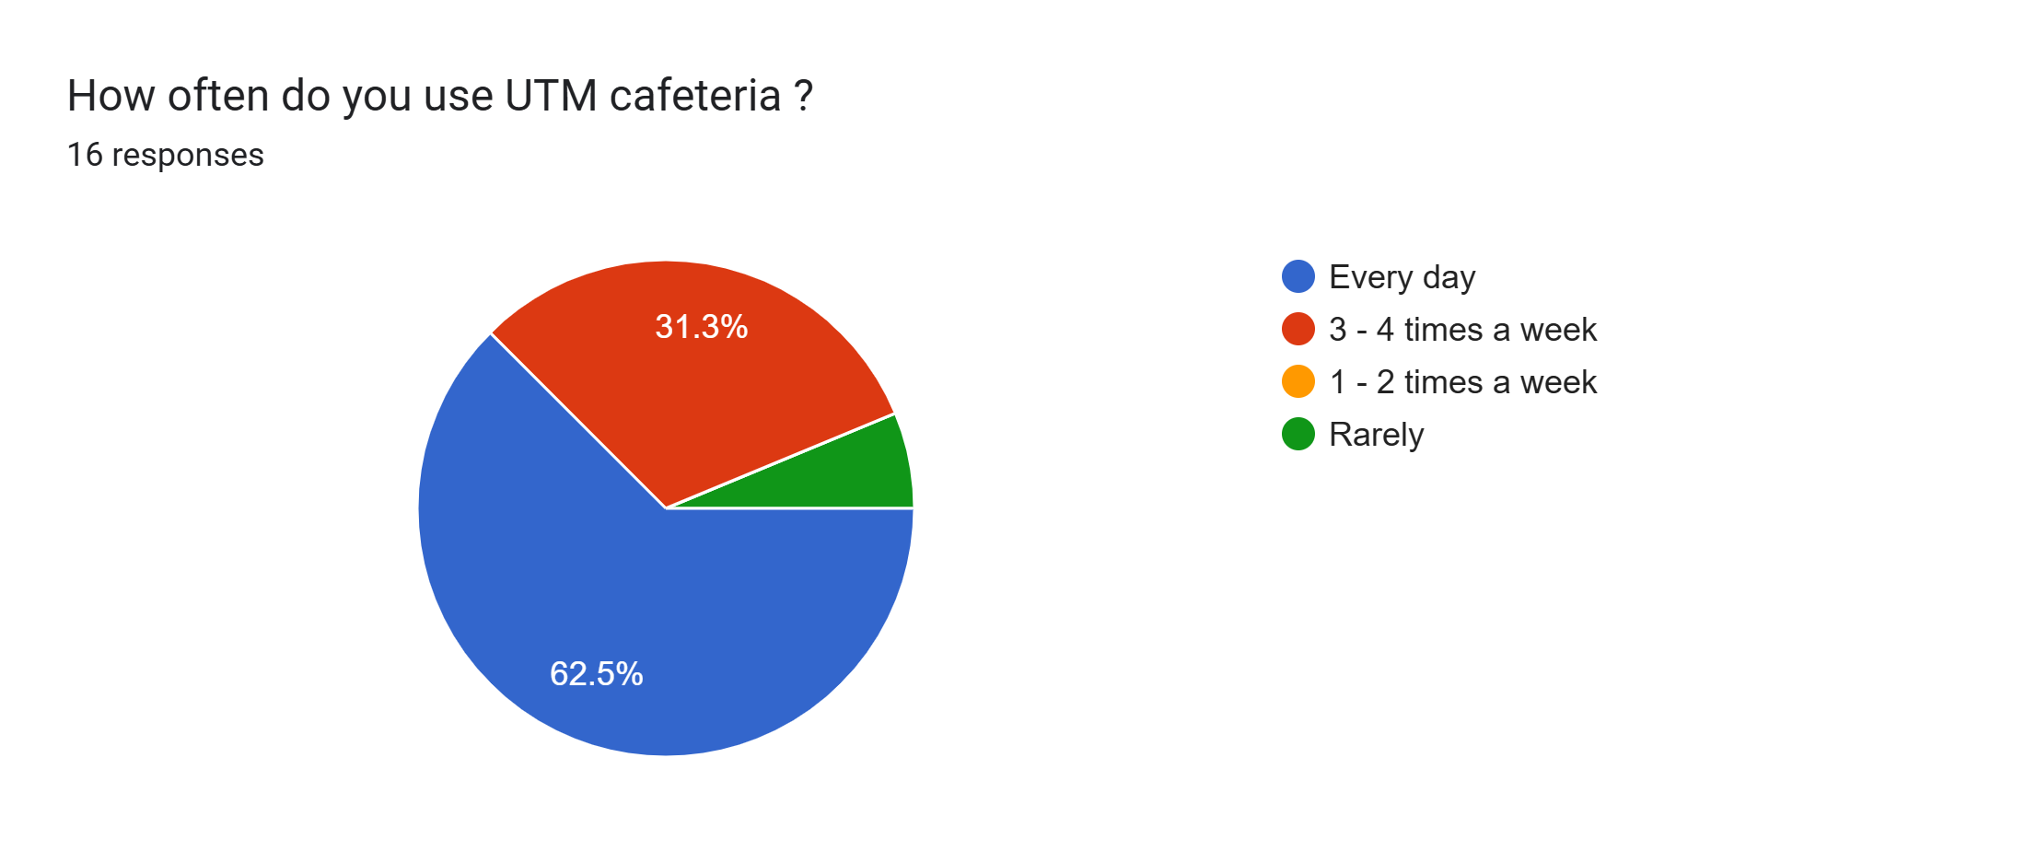 | 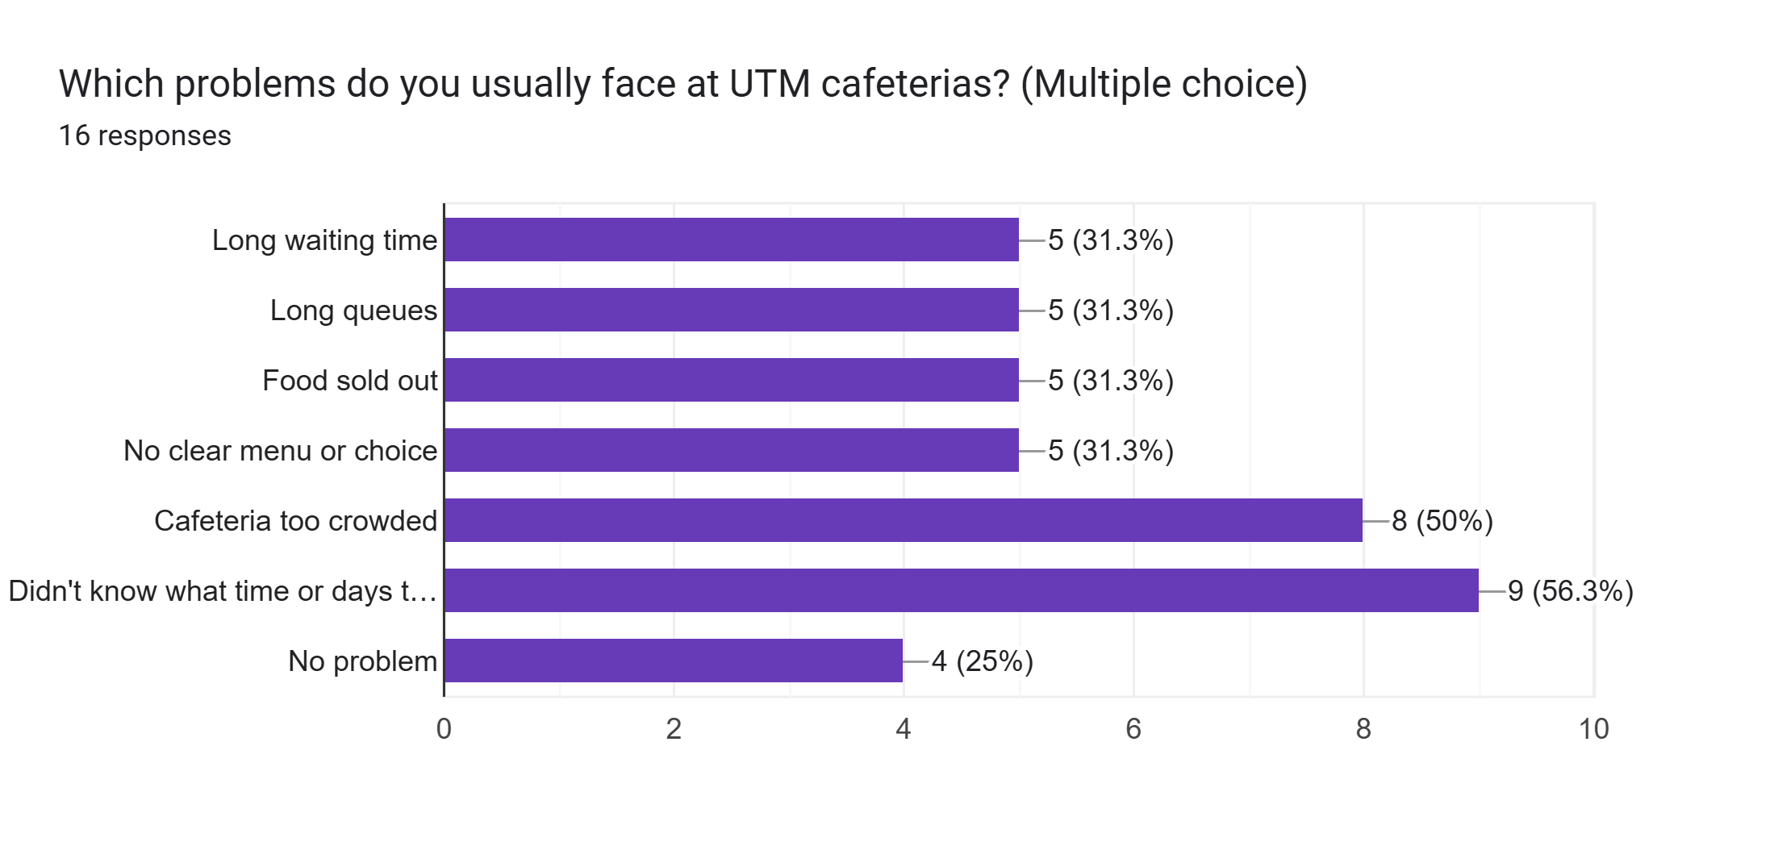
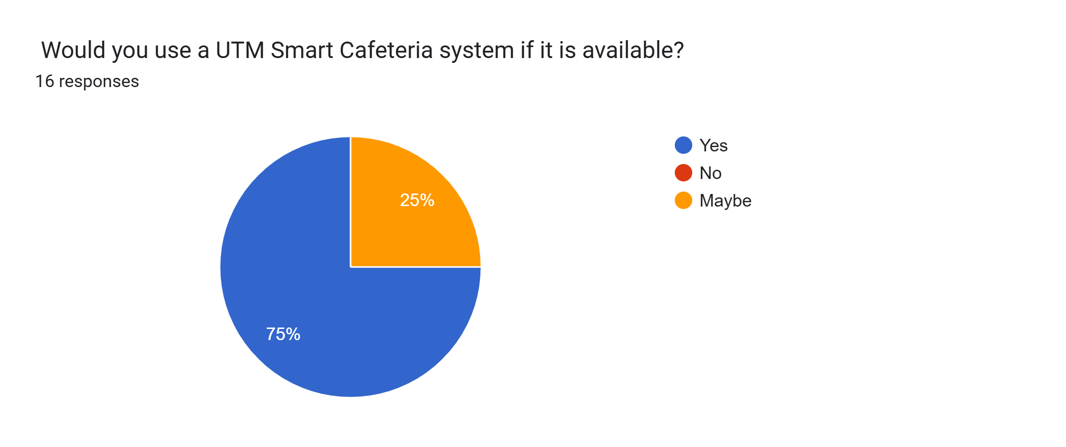 | 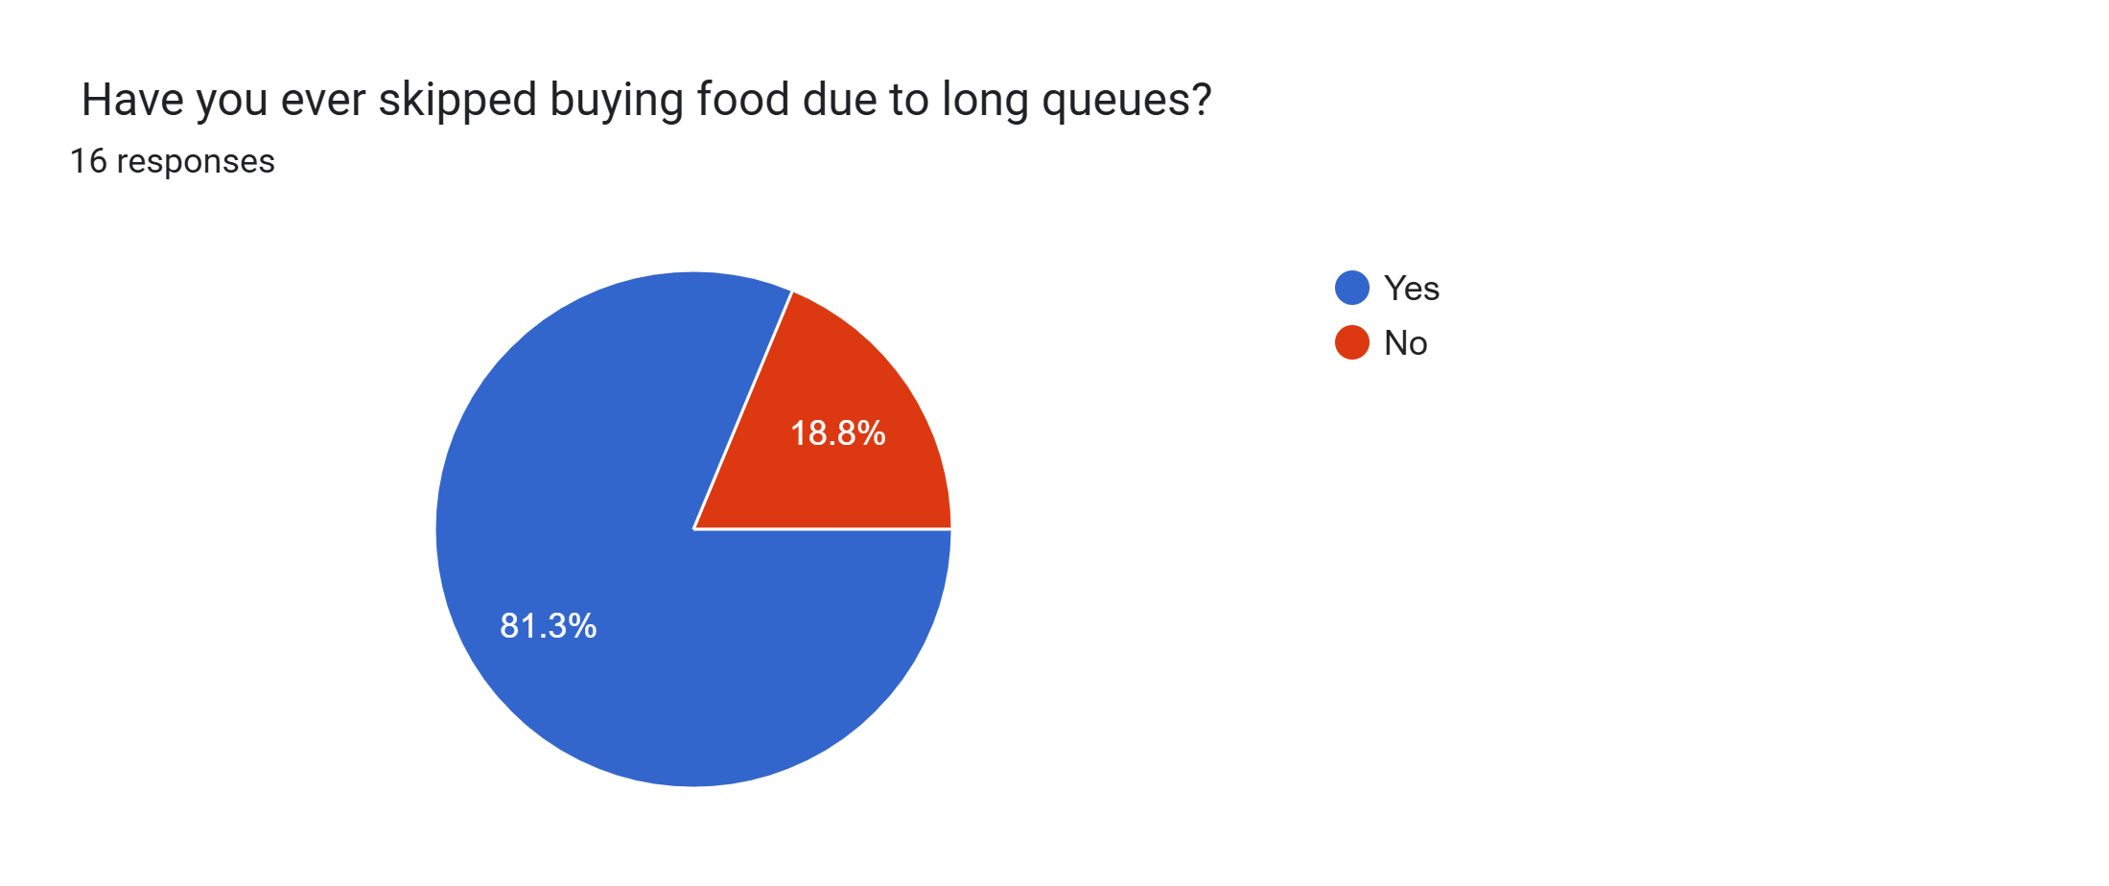

Ideate Phase
During the ideate phase, we discussed to decide the most effective solution. After the brainstorming session, we decided to add a feature which can help students to determine which cafe is crowded also make them easier to see the menu via digital menu.
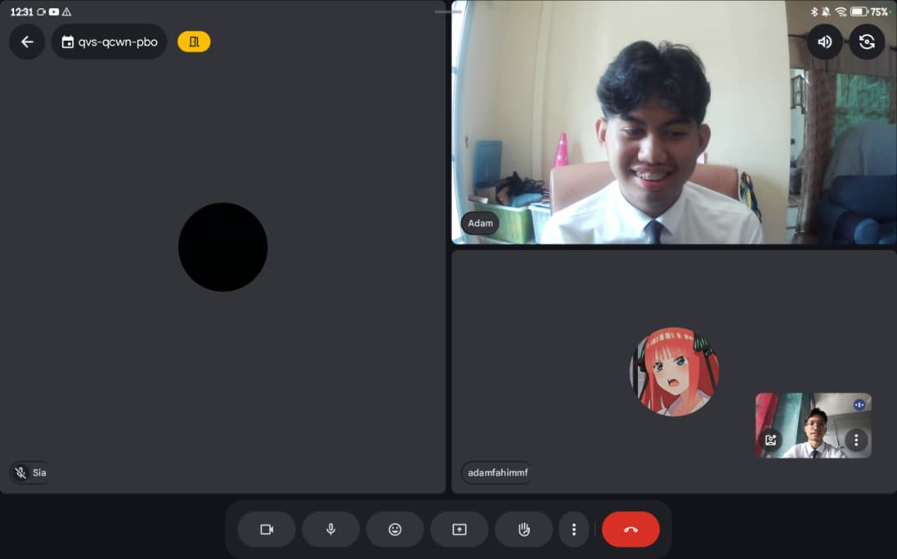

Prototype Phase
During this phase, we created a prototype based on the solution we discussed during the ideate phase.

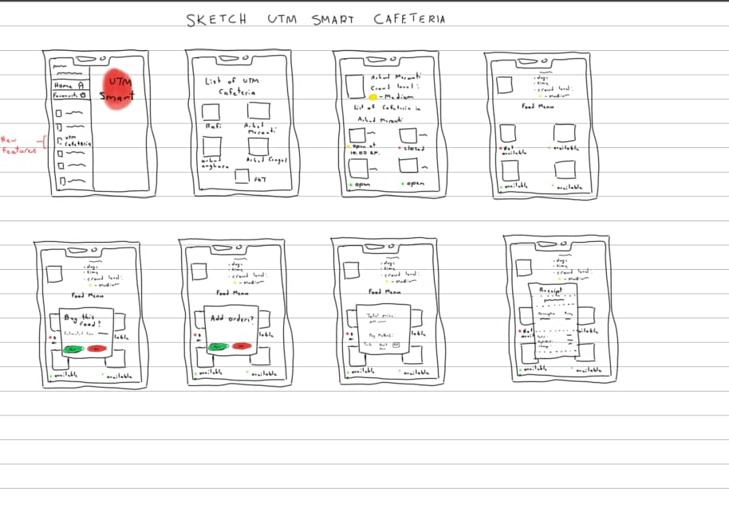

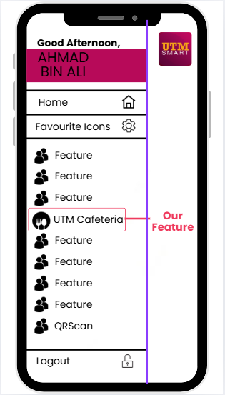 | 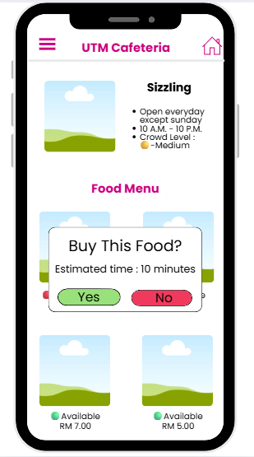

Testing Phase
During the testing phase, we invited some users to try the prototype and share their opinions. They gave positive feedback for the prototype, and it showed that the prototype has met their requirements completely.
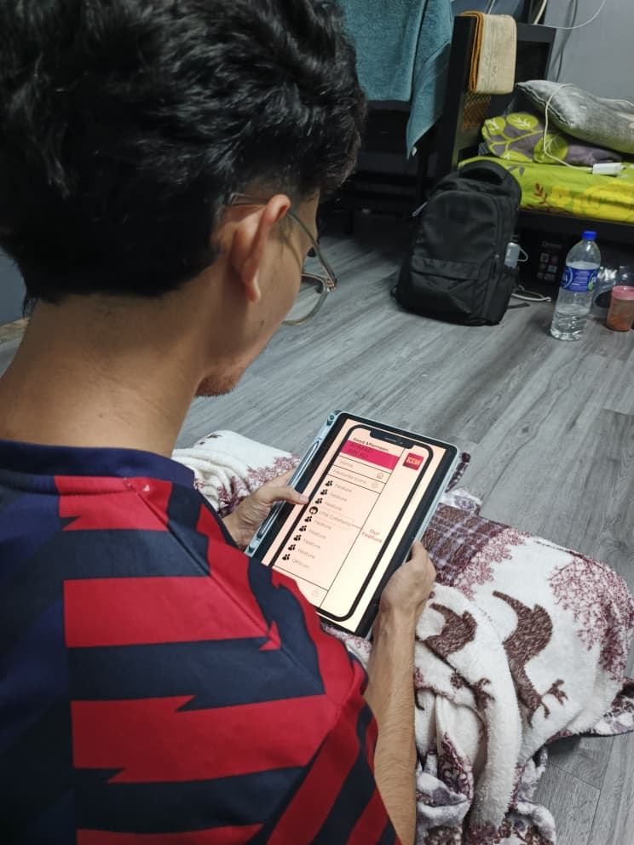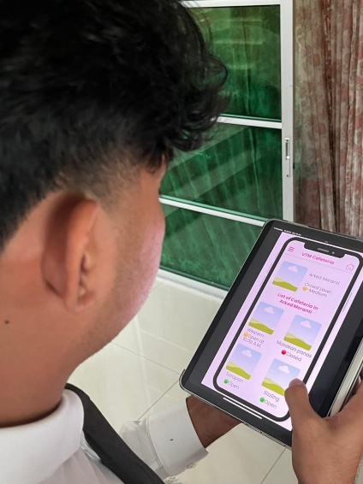

REFLECTIONS

NAME & MATRIX.NO | REFLECTION
AFIF RIFQI BIN SHAIFUL REZAL (A25CS0174) | My goal with regard toward my course is to develop strong problem solving and strengthen my technical skill that can be applied to real-world situations. This design thinking project helped me to identify the user needs and create a practical digital solution. It enhances my mind to think critically and creatively so that the problem can be solve in an efficient way. To improve my potential in the industry, I need to continue improve my technical skills as we know that technology evolves along with time. As a student of computer science, it is very important as it will help increase the job opportunity in computer science industries. Also, I plan to enhance my communication and teamwork skills as we know that in industry we are continuously working as a team instead of working alone. By improving these skills, I will be able to more effectively contribute to team, based projects, and adapt to professional working environments.
ADAM FAHIM MOHD FOAD (A25CS0038) | My aim in this program is to acquire deep knowledge and skills that will make me ready to pursue a career in the technology sector. I wish to create systems that can help to solve real-life situations. Through the design thinking methodology, I have learned to appreciate the need to concentrate my thinking on meeting users' needs. Through empathy for users, understanding their problem definitions before coming up with solutions that need scaling up to full implementation stages, I have learned significant lessons. Through this process, I have enhanced my problem-solving abilities, group work skills, and critical thinking capabilities. All these skills are important for me to acquire if I am to meet my career objectives. To add to my capabilities within the sector, I wish to continue sharpening my skills through project work. I also wish to enhance my communication capabilities to make me a more competent professional system developer.
ADAM BIN BAHARUDDIN (A25CS0170) | My goal in this program is to become a skilled digital innovator who can create solutions that help real users. I want to work on projects that use technology and creativityto slove problems and make a positive impact in the digital industry.  This Design Thinking project taught me that innovation is not only about being creative but also about following a clear process. I learned how to analyse problems carefully, collect useful information, and turn ideas into practical solutions. It also helped me improved my teamwork and communication skills because I had to share my ideas clearly, listen to others, and adapt based on feedback.  To develop my potential, I plan to improve my problem-solving and digital design skills. I also want to joint projects, internships, or competitions to practice real solutions, while on teamwork, communication, and adaptability to become a capable professional in the digital field.
SIA JUN YANG (A25CS0138) | My goal for this course is to learn the skills necessary for building secure and efficient information systems. I hope to join the project that designs technological solutions that both safeguard user privacy and enhance the efficiency of daily lives in the future. This design thinking project has shown me that a successful system depends on understanding user needs. By working on the Detail Description and Evidence sections, I learned to plan functionalities from a system architecture perspective. For example, the Digital Receipt feature I designed reflects the core principles of data integrity and authentication, giving me a clearer understanding of how to implement cybersecurity in real-world applications.  To improve my potential in the industry, I plan to enhance my coding skills and understanding of building a system. I will also strengthen my teamwork and communication abilities, as teamwork is very important to do a project successfully and effectively.

CONCLUSION
Overall, the UTM Smart Cafeteria successfully applies the Design Thinking approach by focusing on user needs, defining clear problems, proposing practical solutions, and evaluating their impact. This system supports UTM’s Smart Campus initiative by creating a more efficient, transparent and user-centered cafeteria experience.

TASK DISTRIBUTION
No. | Name & Matric No. | Task
1 | ADAM FAHIM MOHD FOAD (A25CS0038) | - Report writing (Introduction)  - Report writing (Detail Step)  - Preparing slides  - Reflection  - Data Collection
2 | ADAM BIN BAHARUDDIN (A25CS0170) | - Report writing (Assessment Point)  - Preparing slide  - Google form  - Report writing (conclusion)  - Reflection  - Data collection
3 | SIA JUN YANG (A25CS0138) | - Report writing (Detail description)  - Report wring (Design Thinking Evidence)  - Preparing slides  - Reflection
4 | AFIF RIFQI BIN SHAIFUL REZAL (A25CS0174) | - Google form  - Slide prototype  - Video prototype  - Interview  - Reflection  - Preparing Slide  - Data collection  - Google form

Video link : https://youtu.be/aaZYw5HncQs?si=VLZ5xPmGoK83VRN8

